Isolation Fault

Author：Eason
Reviewer：Steven
FAQ\Hybrid INV
Issue introduction:
The inverter screen displays:Isolation Fault.
Confirmation of basic information
[Photo]SN number of the inverter
Guidance for installer
Step1. Check the time points and frequency of the faults. If they only occur occasionally in the morning, it may be a false detection caused by dew.
Step2. Check the insulation resistance of the inverter's PV string terminals. First, disconnect the AC power supply of the inverter and turn off the battery. Set the multimeter to the highest resistance measurement setting and measure according to the diagram below, ensuring that the ground connection is maintained.

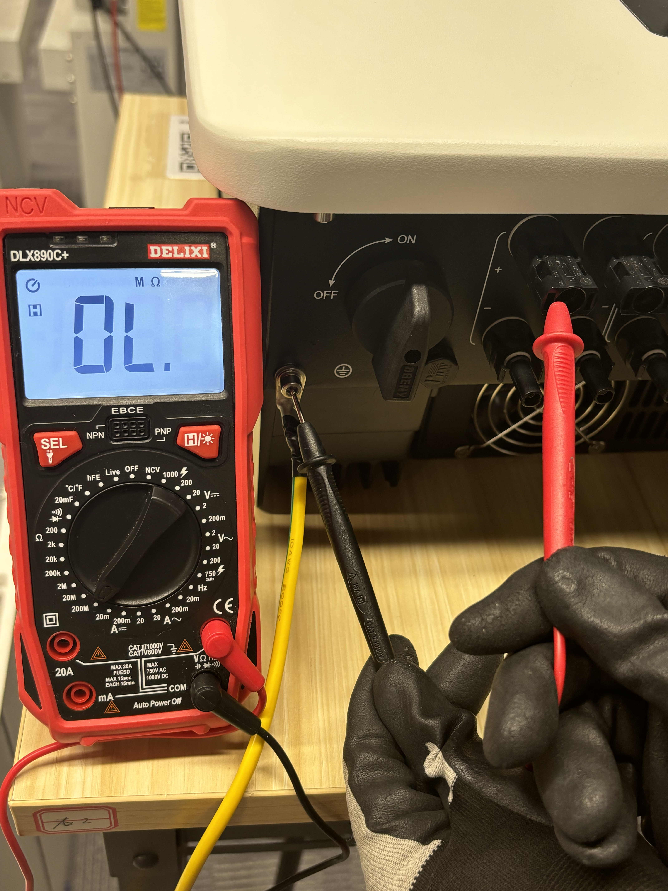
The impedance in the figure has exceeded the maximum range of the multimeter,The measured value needs to be greater than 100 MΩ to be considered safe.
Step3. Turn off the DC switch and the AC power supply, connect a single string of photovoltaic panels, then turn on the DC switch and the AC switch. Check if the inverter reports any errors. Follow this method to connect the photovoltaic panels one by one, identify the faulty string, and remove it.
Step4.If the problem still cannot be identified, measure the positive and negative terminal voltages of each string of photovoltaic panels against the ground. A ground voltage of less than 30V for both the positive and negative terminals is considered normal. If there is a significant difference in the ground voltage between the positive and negative terminals of the same string of photovoltaic panels, for example, one at 100V and the other at 0V, then remove that string of panels.
Information check list
If you have completed the above <Guidance for installer>, and the problem is still not solved, please collect the following troubleshooting information and send them to the R&D.

1.[Photo]SN number of the inverter
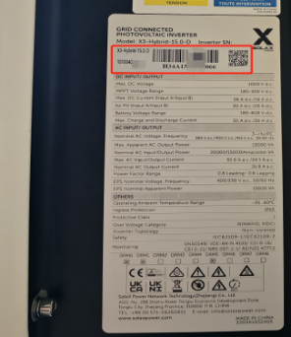
- PV+ impedance to the ground, PV- impedance to the ground.

3. PV voltage between the positive and negative terminals and the ground.

